**Tugas 05**

**Praktikum Pengolahan Citra Digital**

|  |  |  |
| --- | --- | --- |
| Nama  NIM  Jurusan  Link GitHub | :  :  :  : | Fajri Awwaluddin  1207070042  Teknik Elektro 2020  <https://github.com/WA2DE/Tugas_05_PCD.git> |

1. Praktikum 05 - Operasi Dasar Citra

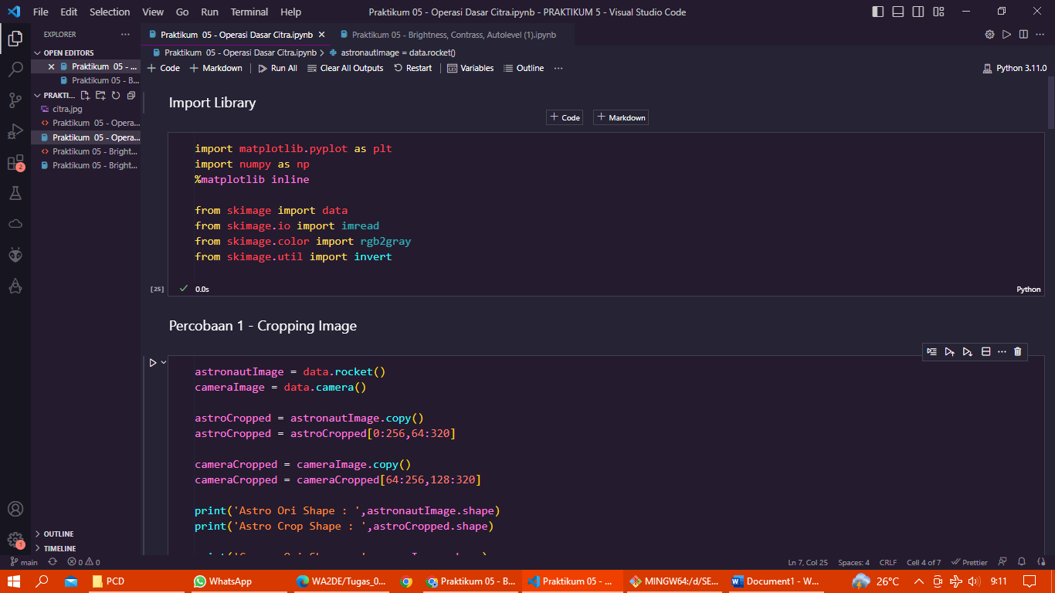

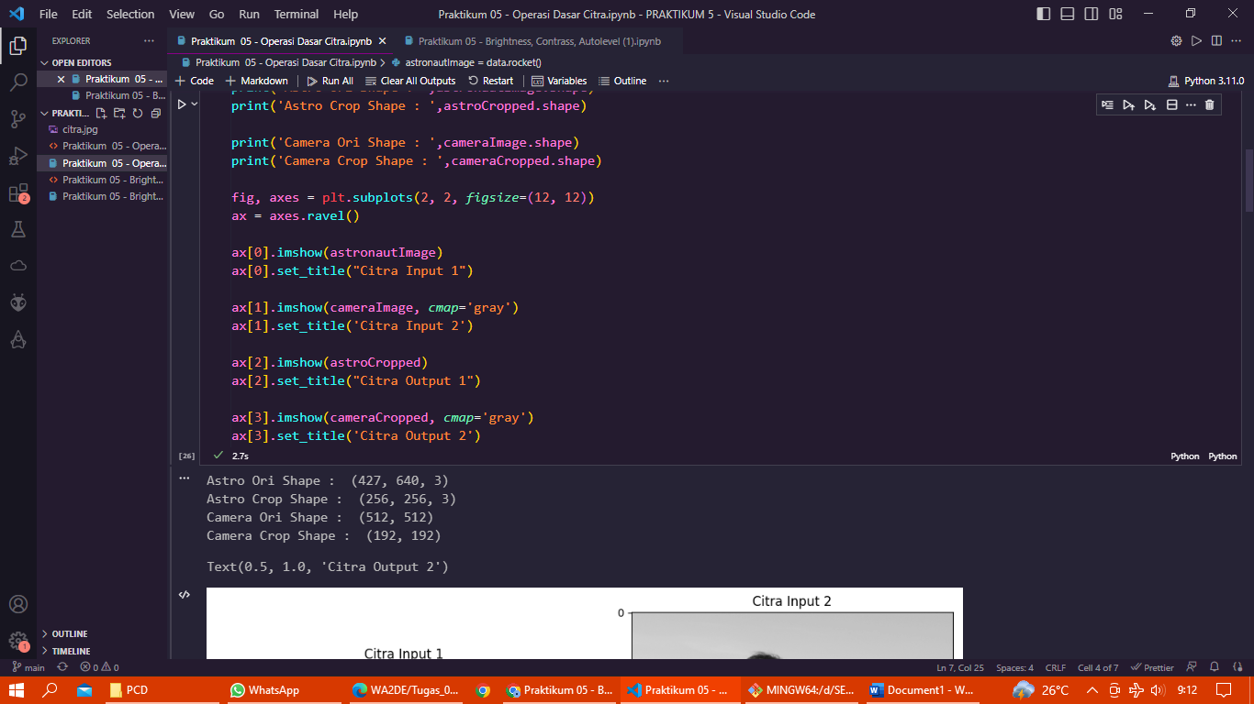

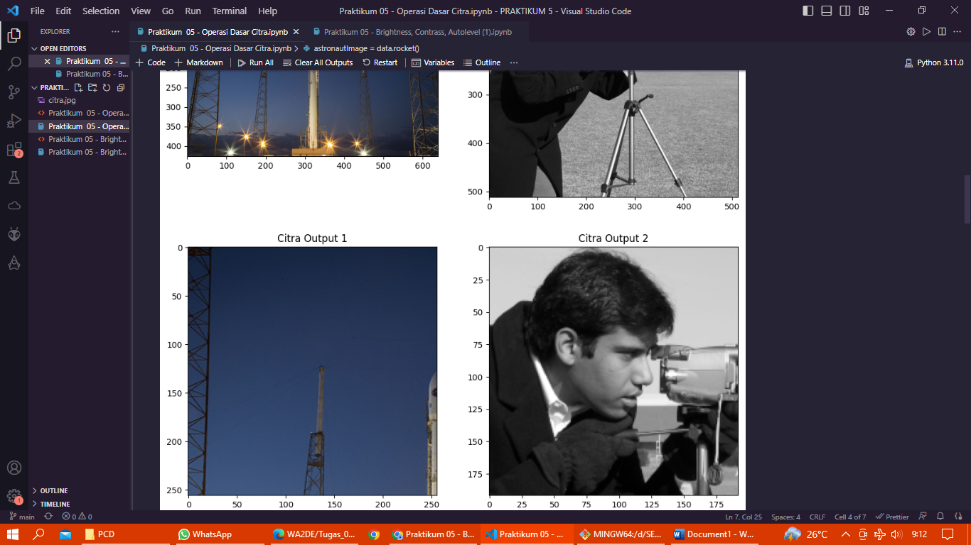

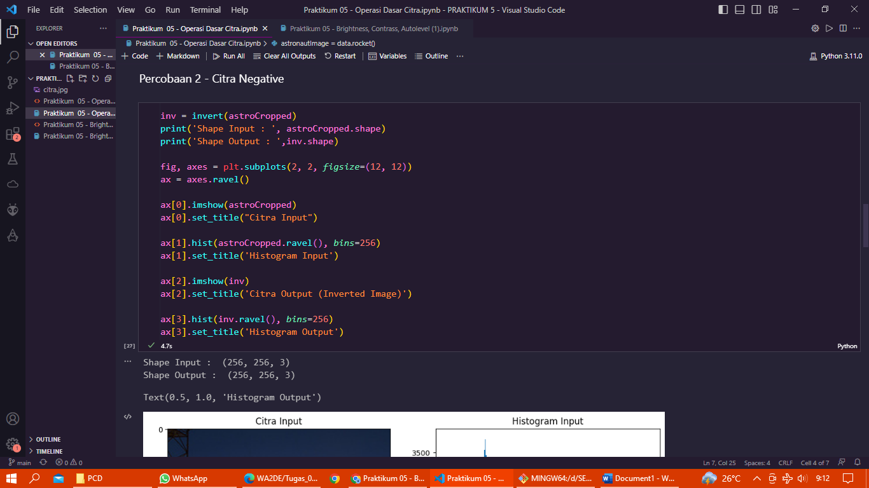

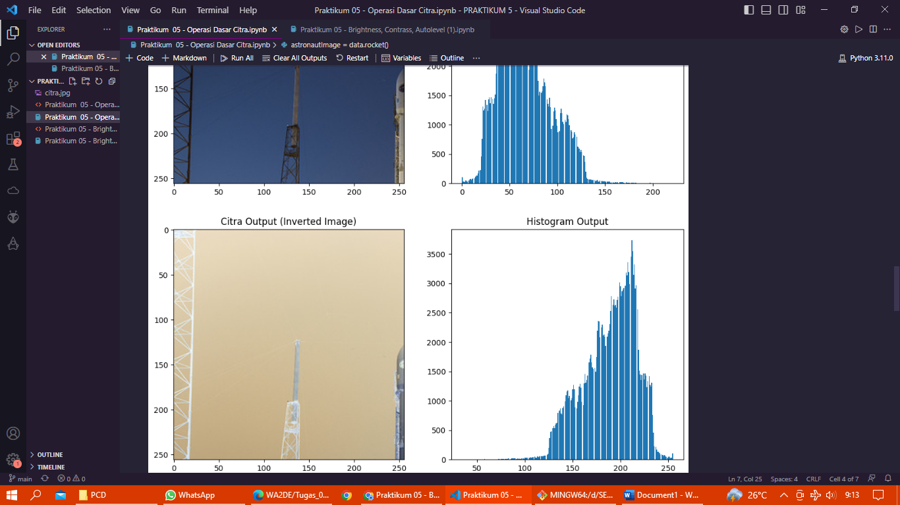

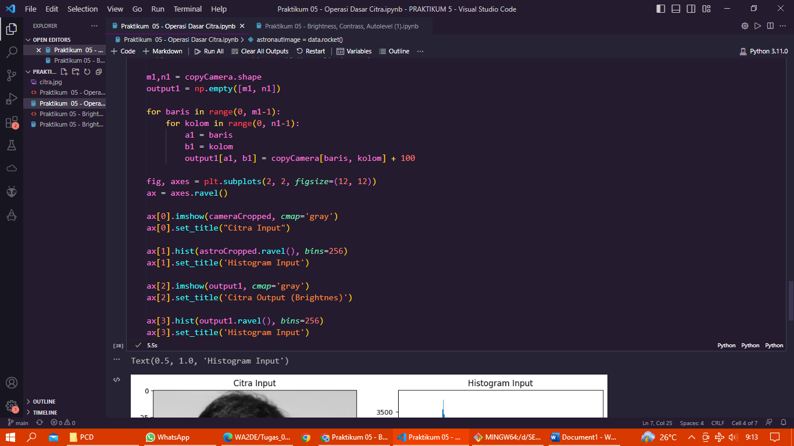

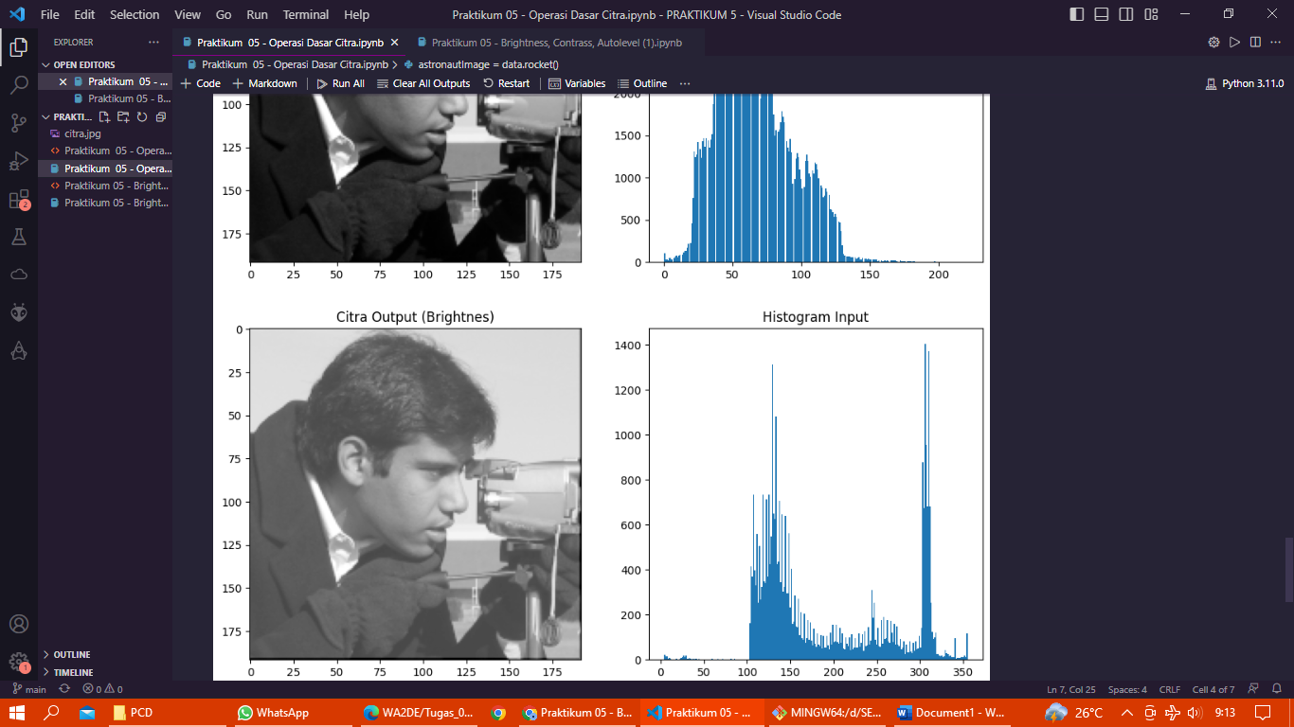

1. Praktikum 05 - Brightness, Contrass, Autolevel (1)

